Submitted To:

Engineer Sheharyar Khan

Name: Iqra Fatima

Reg. Number: 23-CP-62

Semester: 3rd

Department: CPED

Data Structures and Algorithms

(DSA)  
Lab Report 1

# Lab Report 1

**Marks Obtained: 8**

**Total Marks: 8**

**Marks Distribution:**

Total Lab Report Marks: 04

Total Lab Activity Marks: 04

## **Completing Requirements:**

* Installed Python 3.13.1 using the link below:

[**https://www.python.org/downloads/**](https://www.python.org/downloads/)

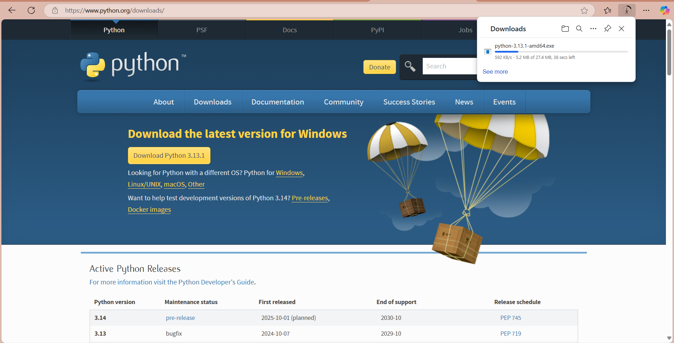

**Run the downloaded .exe file**

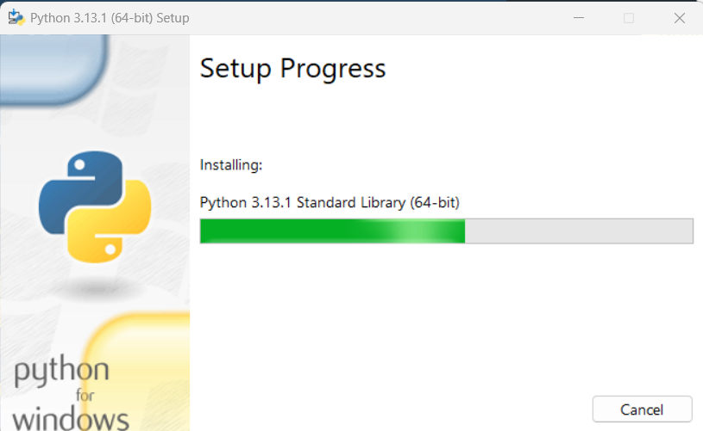

* Installed VS code in my PC from[**https://code.visualstudio.com/**](https://code.visualstudio.com/)

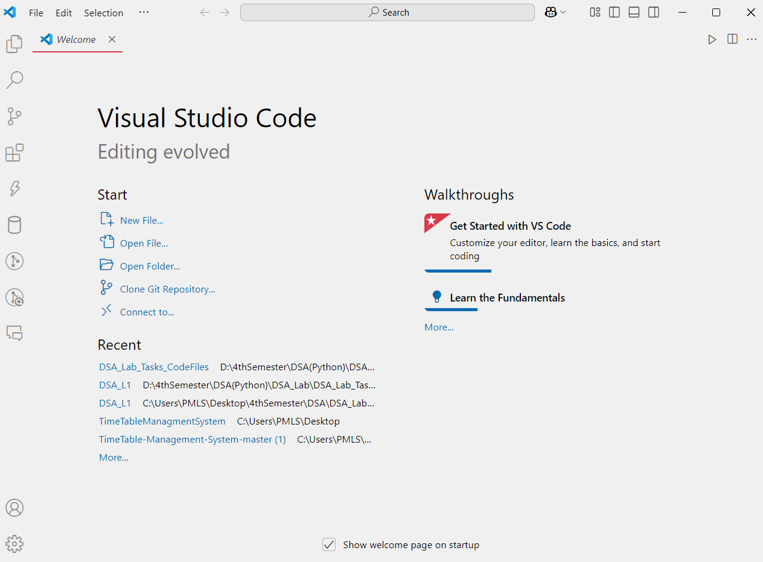

* Verified Python installation through command prompt

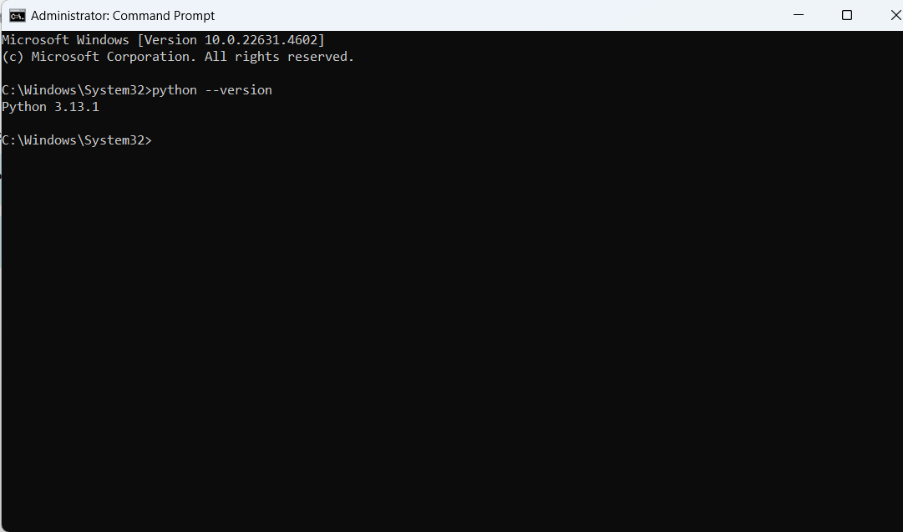

* Installed Python & Code Runner extensions.

**Python Extension**

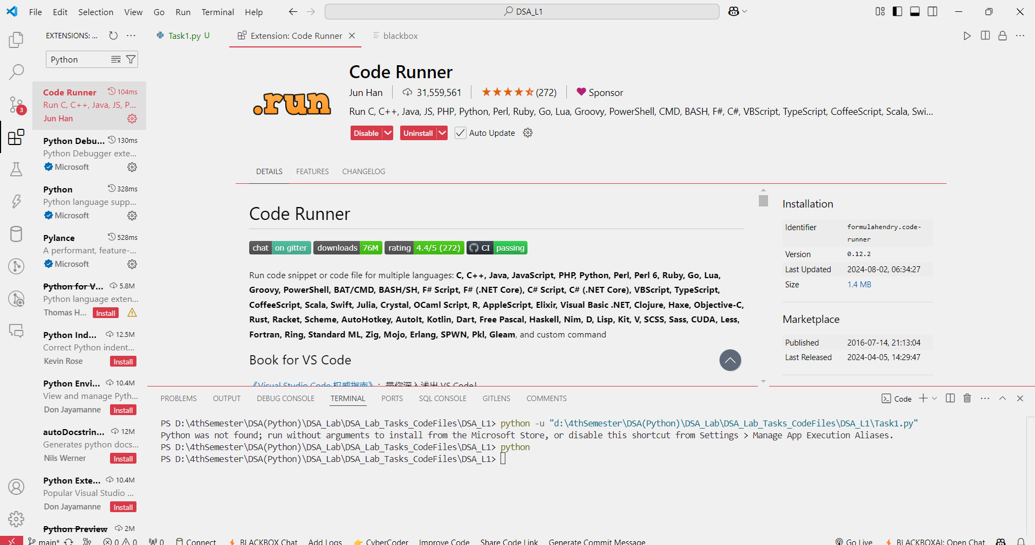

**Code Runner Extension**

* I created separated space as DS_Lab_Tasks_CodeFiles for my Labs Tasks.

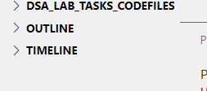

## **Guided Tasks**

### Task 1: Python Variables

#### Code:

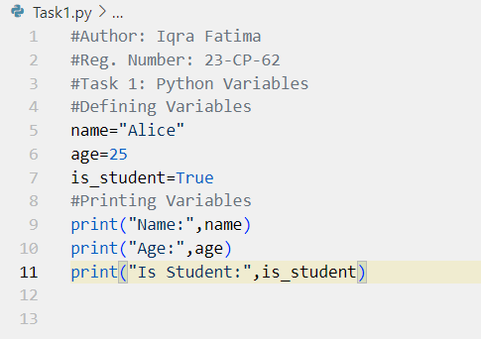

#### Output:

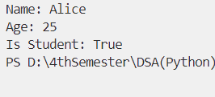

### Task 2: Python Data Types

#### Code:

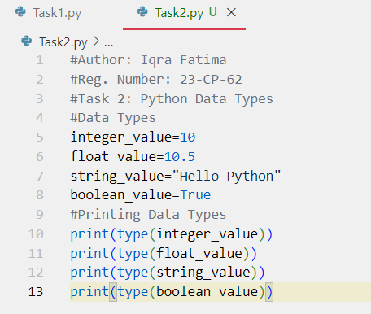

#### Output:

### Task3: Python Numbers and Type Conversions

#### Code:

#### Output:

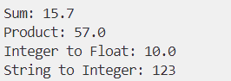

### Task 4: Python Boolean

#### Code:

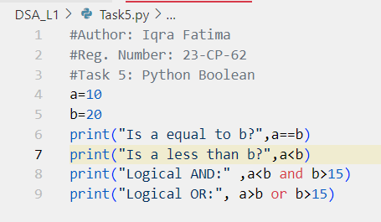

#### Output:

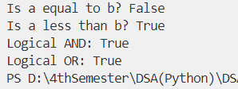

### Task 6: Python Operators

#### Code:

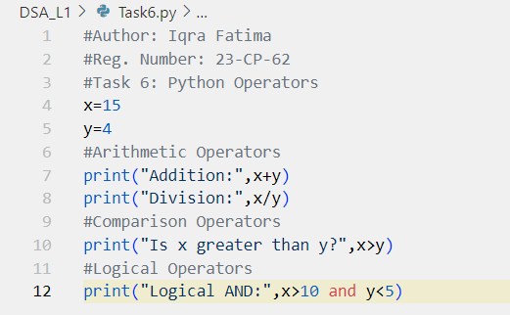

#### Output:

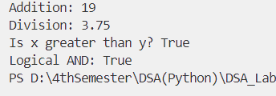

### Task 7: Python Boolean

#### Code:

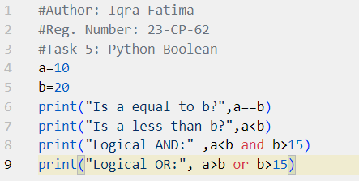

#### Output:

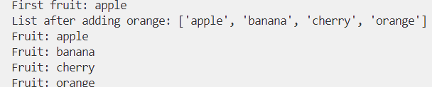

### Task 8: Python Lists

#### Code:

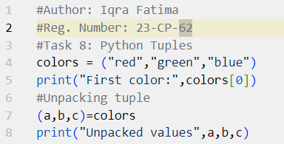

#### Output:



### Task 9: Python Tuples

#### Code:

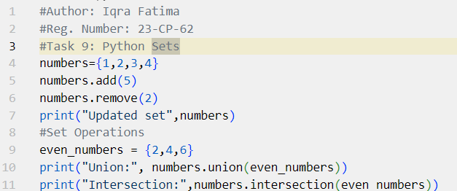

#### Output:

### Task 10: Python Sets

#### Code:

#### Output:

### Task 11: Python If-Else

#### Code:

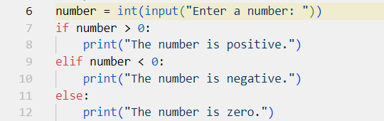

#### Output:



### Task 12: Python While Loop

#### Code:

#### Output:

### Task 13: Python For Loop

#### Code:

#### Output:

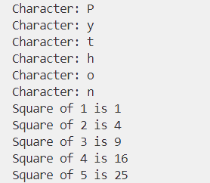

### Task 14: Python Functions

#### Code:

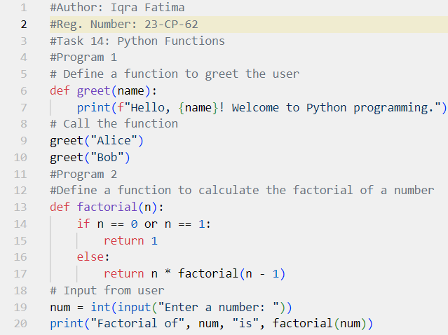

#### Output:

### Task 15: Python Lambda Functions

#### Code:

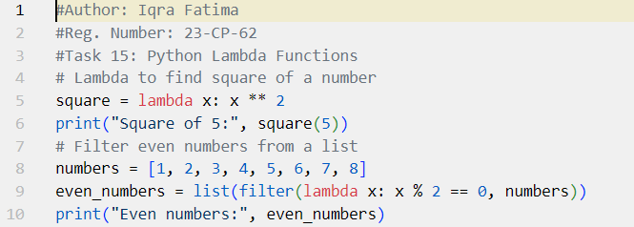

#### Output:

## **Exercise Questions**

### Question 1: Check Positive or Negative

Write a program that takes a number as input and checks whether it is positive, negative, or zero.

#### Code:

number=int(input("Enter a number: "))

if number>0:

    print("The number is positive")

elif number<0:

    print("The number is negative")

else:

    print("The number is zero")

#### Output:



### Question 2: Calculate the Sum of Two Numbers

Write a program to take two numbers as input and print their sum.

#### Code:

num1 = int(input("Enter first number: "))

num2 = int(input("Enter second number: "))

print("Sum of the numbers is:", num1 + num2)

#### Output:



### Question 3: Find the Maximum of Three Numbers

Write a program to input three numbers and print the largest one.

#### Code:

a = int(input("Enter first number: "))

b = int(input("Enter second number: "))

c = int(input("Enter third number: "))

#Now, we'll use if-elif-else statement to find the largest number

if a > b and a > c:

    print("The largest number is", a)

elif b>c:

    print("The largest number is", b)

else:

    print("The largest number is", c)

#### Output:

### Question 4: Reverse a String

Write a program to reverse a string input by the user.

#### Code:

str = input("Enter a string:")

print("Original string:", str)

#Reverse the string

reversed_str = str[::-1]

print("Reversed string:", reversed_str)

#### Output:

### Question 5: Check for Even or Odd Number

Write a program to check if a number is even or odd.

#### Code:

n= int(input("Enter a number:"))

if n % 2 == 0:

print("Even")

else:

print("Odd")

#### Output:



### Question 6: Print Multiplication Table

Write a program to print the multiplication table for a given number (from 1 to 10).

#### Code:

n= int(input("Enter a number:"))

for i in range(1,11):

    print(n,"x",i,"=",n*i

#### Output:

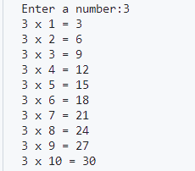

### Question 7: Convert Celsius to Fahrenheit

Write a program to convert a temperature from Celsius to Fahrenheit using the formula:

*Fahrenheit = (Celsius x 9 / 5 ) + 32*

#### Code:

celsius=float(input("Enter temperature in Celsius:"))

fahrenheit=(celsius*9/5)+32

print("Temperature in Fahrenheit:",fahrenheit)

#### Output:



### Question 8: Count the Vowels in a String Write a program to count the number of vowels in a string the user provides.

#### Code:

str = input("Enter a string: ")

vowels = ['a','e','i','o','u','A','E','I','O','U']

count = 0

for i in str:

    if i in vowels:

        count+=1

print("Number of vowels in the string:",count)

#### Output:



Question 9: Calculate the Factorial of a Number  
Write a program to calculate the factorial of a number using a loop.

#### Code:

def factorial(n):

    fact = 1

    for i in range(1,n+1):

        fact = fact * i

    return fact

n = int(input("Enter a number: "))

print("Factorial of",n,"is",factorial(n))

#### Output:



Question 10: Find Prime Numbers in a Range  
Write a program to print all prime numbers between 1 and 50.

#### Code:

def is_prime(n):

    if n <= 1:

        return False

    for i in range(2, int(n**0.5) + 1):

        if n % i == 0:

            return False

    return True

for num in range(1, 51):

    if is_prime(num):

        print(num)

#### Output:

## **Real Life Scenarios**

### Program 1: Electricity Bill Calculation

Write a program to calculate the electricity bill based on the following tariff:

o Up to 100 units: Rs. 30/unit

o 101 to 300 units: Rs. 40/unit

o Above 300 units: Rs. 60/unit

o Meter Rent: 1500

o Additional Tax: 200

Ask the user to input the units consumed and print the total bill.

#### Code:

meter_rent=1500

additional_tax=200

units_consumed=int(input("Enter the units consumed:"))

if units_consumed<=100:

    bill=units_consumed*30+meter_rent+additional_tax

elif units_consumed<=300:

    bill=units_consumed*40+meter_rent+additional_tax

else:

    bill=units_consumed*60+meter_rent+additional_tax

print("Electricity Bill:",bill)

#### Output:



### Program 2: GPA Calculation

Write a program to calculate the GPA of a student.

Input the grades for 5 courses (on a scale of 4.0) and calculate the average GPA.

#### Code:

# Input the grades for 5 courses

g1 = float(input("Enter your grade points in subject 1: "))

g2 = float(input("Enter your grade points in subject 2: "))

g3 = float(input("Enter your grade points in subject 3: "))

g4 = float(input("Enter your grade points in subject 4: "))

g5 = float(input("Enter your grade points in subject 5: "))

# Calculate the average GPA

average_gpa = (g1 + g2 + g3 + g4 + g5) / 5

# Print the average GPA

print("Your average GPA is:", average_gpa)

#### Output:

### Program 3: Monthly Budget Planner

Write a program to help a user plan their monthly budget.

Input the monthly income and expenses for categories like rent, food, transportation,

and savings. Calculate the remaining balance or deficit.

#### Code:

mincome = float(input("Enter your monthly income: "))

rent = float(input("Enter your rent expense: "))

food = float(input("Enter your food expense: "))

transportation = float(input("Enter your transportation expense: "))

savings = float(input("Enter your savings: "))

total_expense = rent + food + transportation + savings

remaining_balance = mincome - total_expense

if remaining_balance > 0:

    print("You have a remaining balance of $", remaining_balance)

else:

    print("You have a deficit of $", -remaining_balance)

#### Output:

### Program 4:

Loan EMI Calculator

Write a program to calculate the EMI (Equated Monthly Installment) for a loan based on

the following formula:

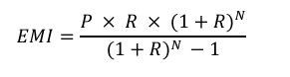

Where:

• P = Principal loan amount

• R = Monthly interest rate (Annual interest rate / 12 / 100)

• N = Number of monthly installments

#### Code:

loan_amount = float(input("Enter the loan amount: "))

annual_interest_rate = float(input("Enter the annual interest rate: "))

monthly_interest_rate = annual_interest_rate / 12 / 100

number_of_installments = int(input("Enter the number of monthly installments: "))

emi = (loan_amount * monthly_interest_rate * (1 + monthly_interest_rate) ** number_of_installments) / ((1 + monthly_interest_rate) ** number_of_installments - 1)

print("The EMI is: ", emi)

#### Output:

